Free Youtube views for an unlimited number of your videos! Boost your video's popularity using their simple and free method! Or, buy Youtube views and other services here.

[ythunder.com](https://ythunder.com/) has free & open registrations.

Audience retention is your video’s ability to keep the attention of your audience all throughout the video, or at least a good portion of it. It is measured as the average percentage of the [YouTube](https://ythunder.com/) video that people watch, so when people generally watch only the first three minutes of a 10-Free Youtube views：[ythunder.com](https://ythunder.com/)

minute video, you will have a retention rate of 30%. [YouTube](https://ythunder.com/) takes this metric seriously, and the safest target for video creators is a retention rate of 50% and above. Remember that the higher a video’s retention rate,  ishe more visible it will be on [YouTube](https://ythunder.com/), and the higher it will rank in search results.

To view how your videos are doing in terms of audience retention, simply log in to [YouTube](https://ythunder.com/), go to your channel and play a video. Click on the analytics button at the bottom of the video, alongside the video title and description. You will be taken to the analytics page and you will see the average view duration in minutes and percentages.

[YouTube](https://ythunder.com/) has made it easy for video creators to track the retention rate of their videos by incorporating it with their analytics. This way, you can focus your time and energy towards increasing video audience retention on [YouTube](https://ythunder.com/). Here are effective ways to do this:

**Analyze your videos for better video audience retention**

You can’t just upload a video and leave it there, hoping Free Youtube views：[ythunder.com](https://ythunder.com/)

against hope that people will watch it and your future videos. Make it a point to take advantage of the [YouTube](https://ythunder.com/) analytics feature and find out how your videos are doing. Analyze the retention rate of your previous videos and learn from them.

A high relative retention rate (50% and above) is good and means that viewers kept watching more than half of your video. The *relative* retention rate is the percentage you immediately see in the Audience retention box in the Analytics section. You will also need to look at the *absolute* retention to see at what point most viewers tend to leave. You can see the absolute retention rate by hovering your mouse over certain points on the graph.

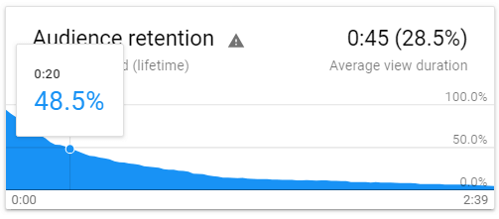

The example in the image above shows that more than half of viewers don’t make it past 20 seconds of the 2.5-minute video. The absolute retention rate just dives down after that, as shown in the graph. As a result, the relative retention rate is only at 28.5%.

Knowing at which point of a video most viewers drop off will tell you that they’ve lost interest and you have to do something about it when creating your next videos. Also, look at your videos with a high audience retention and analyze what made viewers stay.

**Start right away**

When you see that viewers tend to drop off in the first 10 to 20 seconds of your video, that tells you that your intro is uninteresting or off-topic. From the very beginning, give your audience what you promised. If your video title says “How to Edit Videos for [YouTube](https://ythunder.com/),” get on with it right away instead of telling the viewers first about trivial things like what you ate earlier or how [YouTube](https://ythunder.com/) changed your life.

Let your viewers know right away what they are getting from your video so that they will stay.

**Do keyword research for better retention**

[YouTube](https://ythunder.com/) is fun, but it’s not all about that for most video creators. There’s a lot of hard work behind the scenes, and keyword research is one of them.

The most viewed videos address a problem, meet a need or want, and add value. By researching keywords correctly, you will know what your target audience is looking for and you can create content based on it. Use Google and [YouTube](https://ythunder.com/)’s auto suggest feature. For example, if your niche is plumbing, and you type that word in the search bar, [YouTube](https://ythunder.com/) will suggest the topics that most people search for.

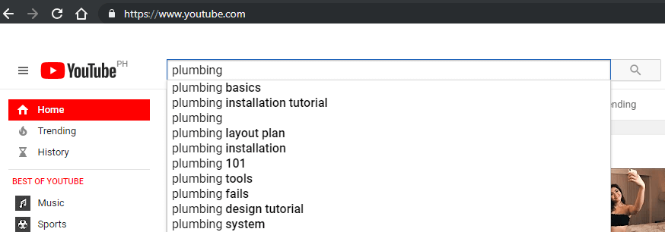

Another way to find keywords is to look at the source code of a competitor’s videos. Go to the video with the highest views, right click on the page, and select “View page source.” Find the word “keyword” and you’ll see all the keywords your competitor used in that video.



List the suggestions and the keywords from the competitors, and use a keyword planner such as Kparser or Keywordtool.io to check the search volume, trends, and how competitive the keywords are.

**Break the monotony**

Staring at the same thing for more than one minute can get boring, and this can make viewers lose interest and move on to the next video. Your audience retention rate will suffer because of this.

To avoid this scenario, change the screen on your videos every few seconds by using B-roll, cards, graphics, and text. Here’s an enlightening video of how B-rolls can make a difference in any type of video.

If you are shooting a how-to video, move around from left to right, or zoom in and out. Make sure that you give your viewers a dynamic viewing experience so they will stay through the end.

**Make your videos the right length**

A lot of people talk about how viewers’ attention span are shorter these days, so video creators should keep their videos short – like two minutes short. Is shorter really better? According to [YouTube](https://ythunder.com/), this is not the case. Keeping videos shorter to increase retention rate will not work with [YouTube](https://ythunder.com/)’s focus on promoting videos that contributes to a “longer viewing session on [YouTube](https://ythunder.com/).” Here’s an exercise: search for something on [YouTube](https://ythunder.com/) and look at the length of the first few videos shown in the search results.

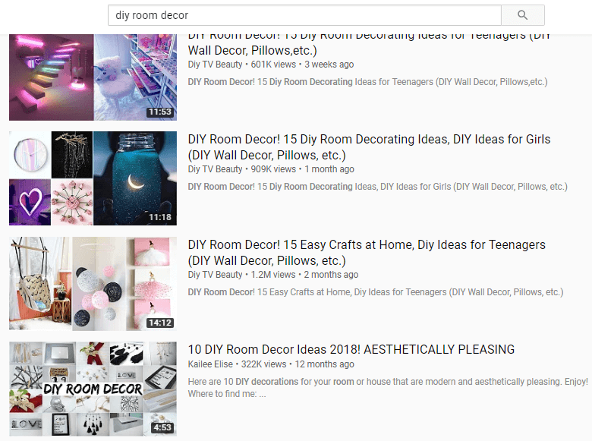

We searched for “diy room decor” as an example, and the first three videos are more than ten minutes long. There are shorter videos, of course, but they are way down the search results page.

Interestingly, making longer videos for the sole purpose of increasing watch time will not necessarily work either. Keep in mind that your viewers are intelligent beings and they will know if you are dragging the video out just to keep them watching.

The key is to create videos with the viewer’s’ interest in mind, which is why keyword research and keeping your content relevant to the keywords are very important. Whether you need three minutes or 24 minutes to get your message across shouldn’t matter as long as the video is what your viewers need.

Increase your [YouTube](https://ythunder.com/) video audience retention

We talked about five methods of increasing your video audience retention on [YouTube](https://ythunder.com/), and all of them focused on creating content which is:

* Based on the most effective keywords
* Visually appealing
* Of the right length
* What your target audience actually needs or wants

It’s also not enough to upload a video and leave them there. You need to analyze how they are doing, which is primarily why there’s a [YouTube](https://ythunder.com/) analytics functionality. Take advantage of it and other [YouTube](https://ythunder.com/) statistics platforms, analyze your numbers, and create your next video with the analysis in mind.Free Youtube views for an unlimited number of your videos! Boost your video's popularity using their simple and free method! Or, buy Youtube views and other services here.

[ythunder.com](https://ythunder.com/) has free & open registrations.